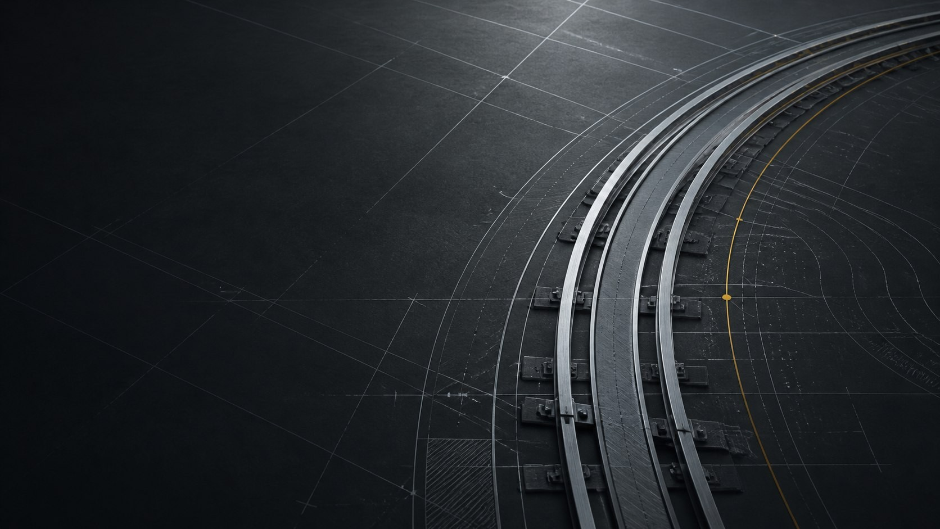
CAPABILITIES STATEMENT | 2026

BUILT FOR THE HARDEST MILES.
  - Rail construction, rehabilitation, maintenance, transit, inspection, heavy transport, and derailment response across Western Canada.
35+  YEARS OPERATING | 3  PROVINCES SERVED | 4  CONSECUTIVE PUBLIC SELECTIONS | 7 days  TRACK INSPECTIONS
IRONHORSE RAILROAD CONTRACTORS LTD. | CROSSFIELD, ALBERTA

01 | COMPANY

ONE ACCOUNTABLE RAIL CONTRACTOR.
  - Canadian-owned and reporting more than 35 years of operation, Ironhorse combines experienced rail crews with specialized railway, hi-rail, and transport equipment.

OPERATING FOOTPRINT
Primary dispatch is based in Crossfield, Alberta, with project mobilization across Alberta, British Columbia, and Saskatchewan. Teams support industrial, shortline, mainline, municipal, transit, grain, mining, energy, and commercial rail users.
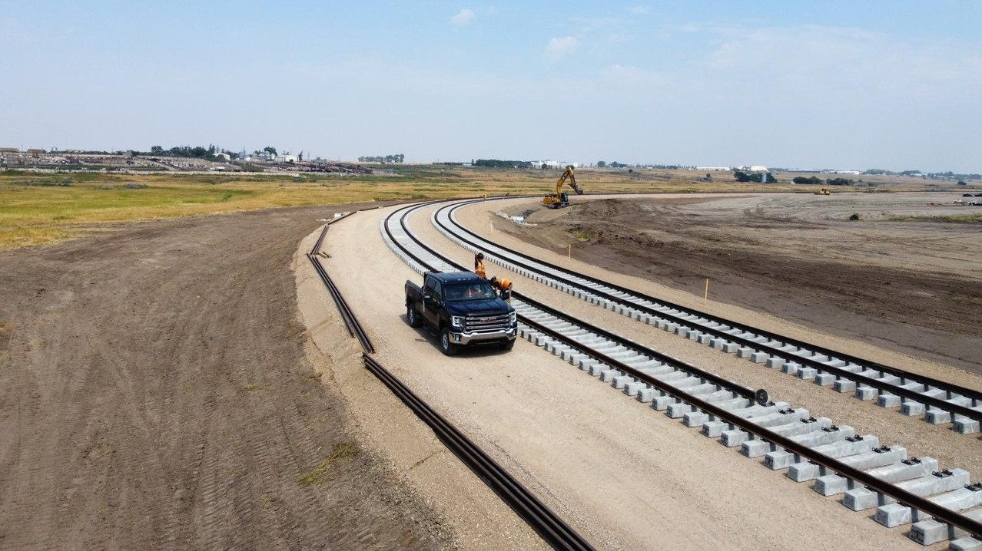

WHAT PROCUREMENT TEAMS GAIN
- One contractor coordinating field crews, specialized railway equipment, heavy transport, and project support.
- A lifecycle capability that extends from new construction through inspection, rehabilitation, surfacing, emergency repair, and ongoing maintenance.
- Regional experience planning around operating windows, live-track interfaces, access constraints, and material flow.
- Derailment inquiries at 403-946-0169; confirm crew and equipment availability by phone.

02 | SERVICES

ELEVEN CONNECTED CAPABILITIES.
  - A delivery model designed to reduce handoffs and keep responsibility clear from scope definition through handback.
CAPABILITY | DELIVERY SCOPE
New track construction | Industrial spurs, yards, loop tracks, turnouts, ballast, rail, surfacing, and commissioning support.
Track rehabilitation | Tie, rail, turnout, fastening, drainage, undercutting, and ballast renewal programs.
Emergency response | Derailment clearing, re-railing support, track rebuilds, surfacing, and return-to-service coordination.
Thermite welding | Joint elimination, pull-aparts, broken-rail repair, continuous welded rail, grinding, and inspection.
Production surfacing | Tamping, lining, regulating, turnout work, geometry correction, and transit right-of-way surfacing.
Tie and steel gangs | Production tie renewal, rail relay, fastening, anchoring, gauge restoration, and finished surfacing.
Transit maintenance | Preventive maintenance, upgrades, closure-based delivery, and purpose-built narrow-profile equipment.
Track inspections | TIGS-trained inspection personnel, condition reporting, maintenance priorities, and repair scoping.
Track protection | Qualified flagging and protection for utility, municipal, contractor, transit, and maintenance work.
Fire and asset prevention | Hi-rail water equipment, fire watch, hot-work support, and trackside asset wetting.
Transport and equipment | Heavy haul, hot shot, equipment rentals, selected sales, and in-person training.

03 | FLEET

SPECIALIZED RAIL FLEET.
  - Ironhorse supports field delivery with railway production machines, hi-rail equipment, heavy transport, and material handling.
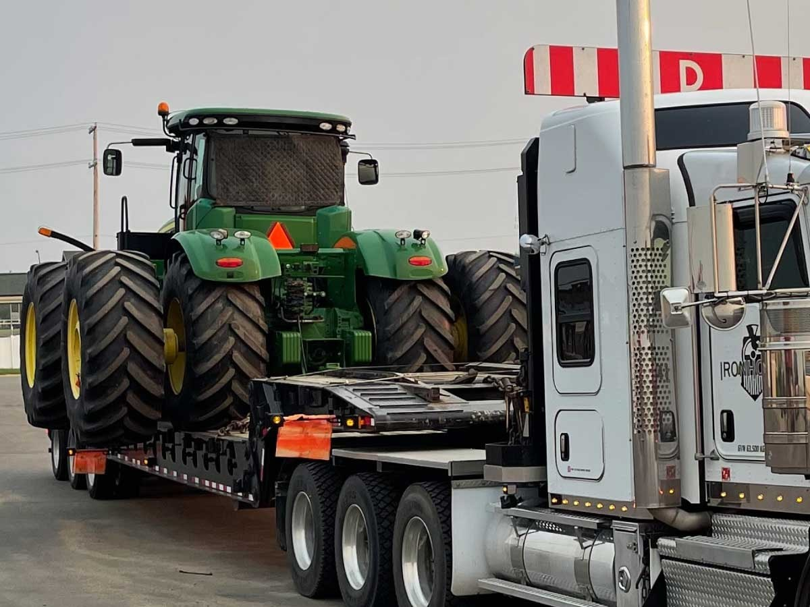

TRACK PRODUCTION
MKIV tampers, the in-house Jupiter II transit surfacing system, ballast regulators, tie handlers, anchor units, and Gopher and Super Gopher undercutters.

HI-RAIL AND SUPPORT
Hi-rail excavators with rail attachments, backhoes, boom trucks with grapples and magnets, loaders, inspection vehicles, and fire-prevention water trucks.

HEAVY TRANSPORT
Kenworth T800 and W900 tri-drive tractors, winches, scissor-neck and lowboy trailers, plus one-ton hot shot service with a 40-foot gooseneck.
16,000 L  Fire truck tank | 2,050 LPM  Pump output | 100 to 150 ft  Front-cannon reach | 80 ft  Side coverage

04 | EVIDENCE

WORK NAMED IN PUBLIC RECORDS.
  - Government records, owner acknowledgements, and completion notices independently document Ironhorse project participation.
$8M  COALDALE PROJECT VALUE | 1.6 km  NEW INDUSTRIAL SPUR | 4  LETHBRIDGE SELECTIONS | 2027  CURRENT COR EXPIRY

COALDALE INDUSTRIAL RAIL SPUR
Alberta's Major Projects registry names Ironhorse as one of two contractors on the completed $8 million Coaldale industrial rail spur. The 1.6-kilometre project connects the industrial park and NewCold facility to the CPKC main line. The public record does not divide the value or scope between the two contractors.
Source: Government of Alberta Major Projects registry | View public record

FOUR CONSECUTIVE CITY OF LETHBRIDGE SELECTIONS
Public records identify Ironhorse for the City's annual railway rehabilitation work in 2022, 2023, 2024, and 2025. Published values were $493,919.27 in 2022, $493,919.27 in 2023, $693,913.28 in 2024, and $576,473.55 in 2025.
Source: City of Lethbridge procurement summary, 2022 | View public record
Source: City of Lethbridge procurement summary, 2023 | View public record
Source: City of Lethbridge procurement summary, 2024 | View public record
Source: City of Lethbridge tender result, 2025 | View public record

PASSENGER AND HERITAGE RAIL
A Journal of Commerce completion record names VIA Rail Canada as owner and Ironhorse as contractor for Jasper track work.
Source: Journal of Commerce certificate archive, VIA Rail Jasper track work | View public record
The Western Development Museum separately credits Ironhorse for rebuilding the track supporting Short Line 101 in Moose Jaw, Saskatchewan.
Source: Western Development Museum, K+S Potash Canada Short Line 101 | View public record

05 | READINESS

CURRENT SAFETY STANDING.
  - A current Certificate of Recognition and a clear project-document process support owner prequalification.
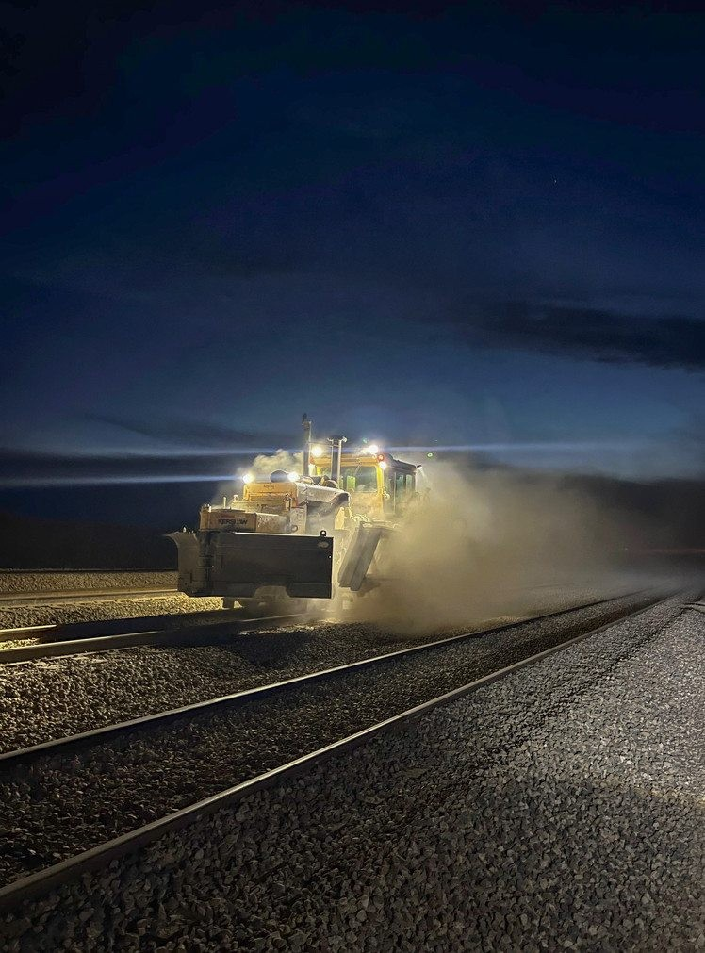

ALBERTA CERTIFICATE OF RECOGNITION
The Government of Alberta's current COR holder list records Ironhorse Railroad Contractors Ltd., COR number 20241230-0597, certified through the Alberta Construction Safety Association and expiring December 30, 2027.
Source: Government of Alberta, current COR holder list | View public record

AVAILABLE FOR PROJECT REVIEW
- Current safety, insurance, personnel, and equipment documentation
- Project-specific mobilization, access, protection, and operating plans
- Relevant project references and public evidence links
- Equipment availability and operator information confirmed against the requested dates
Evidence standard: published values and roles are described exactly as recorded by the source. Representative operating photography is not presented as documentation of a specific public contract.

06 | PROJECT DESK

PUT A PRACTICAL SCOPE IN FRONT OF US.
  - Send the location, work required, known track details, target schedule, and available plans. Ironhorse will assemble the right field and equipment response.

USEFUL BID INPUTS
- Nearest town, facility, subdivision, and milepost
- Track length, rail weight, turnout count, car types, volumes, and known defects
- Required standards, access limits, protection requirements, and operating windows
- Target dates, material responsibilities, drawings, photos, and available inspection reports
PROJECT AND GENERAL INQUIRIES | info@ironhorserail.com
PHONE / DERAILMENT INQUIRIES | 403-946-0169
HEAD OFFICE | 1412 Railway St, Crossfield, Alberta T0M 0S0
IRONHORSERAIL.COM

